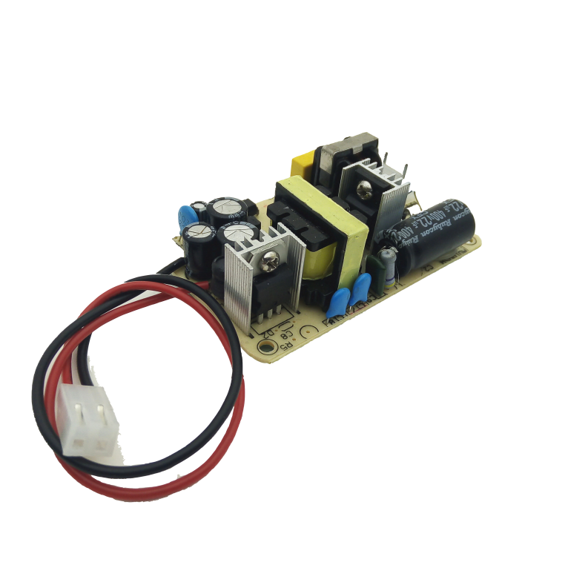

|  |  |  |  |  |  |  |  |  |  |  |  |  |  |  |  |  |  |  |  |  |  |  |  |  |  |  |  |  |  |  |  |  |  |  |  |  |  |  |  |  |  |  |  |  |  |  |  |  |
| --- | --- | --- | --- | --- | --- | --- | --- | --- | --- | --- | --- | --- | --- | --- | --- | --- | --- | --- | --- | --- | --- | --- | --- | --- | --- | --- | --- | --- | --- | --- | --- | --- | --- | --- | --- | --- | --- | --- | --- | --- | --- | --- | --- | --- | --- | --- | --- | --- |
| |  |  |  |  | | --- | --- | --- | --- | | ● | 宽输入电压适应特性 | | | | ● | 一体化芯片设计，具有良好的一致性 | | | | ● | 宽电压输入范围，可自动适应世界范围供电 | | | | ● | 空载功耗小于0.5W，符合能源之星管理标准 | | | | ● | 内设浪涌吸收电路，对电瞬变脉冲群，有抑制作用 | | | | ● | 高于1%的输出电压精度 | | | | ● | 短路、过载、过热自动保护 |  |  | | ● | 100%满负载老化测试 | |  | | ● | 高效率、长寿命和高可靠性设计 | | | | ● | 自然冷却 | | | | ● | 18个月质保 | | | |  | |  |  |
|  |  | | |  |
|  |  | | |  |
|  |  |  |  |  |
|  |  | |  |  |
|  |  | | |  |
|  |  | | | |
|  |  | | | |
|  |  | | | |

|  |  |  |
| --- | --- | --- |
| 产品名称  **输入输出特性** | | 开板电源 |
| 直流 输入 | 输入电压范围 | DC48V（36-72） |
| 频率 | 0 |
| 电流 | 0.27 |
| 启动冲击电流 | 1 |
| 转换效率 | 78 |
| 泄漏电流 | 5MA |
| 交流 输入 | 输入电压范围 | AC85-265V（最高可短时间承受输入300V过电压） |
| 频率 | 47-63HZ |
| 电流 | ＜1000mA |
| 启动冲击电流 | ＜30A@ac240V输入时 |
| 转换效率 | 75%（220V标称输入时） |
| 泄漏电流 | ＜0.25mA |
| 输出 | 直流电压 | 标称输出5.10V |
| 电流范围 | 0-1000mA |
| 额定功率 | 10W |
| 峰值输出功率 | 15W |
| 纹波噪声（峰峰值） | 50mV |
| 稳压精度 | 1% |
| 源效应： | 1% |
| 负载效应 | 1% |
| 启动时间 | ＜2S |
| 温度系数 | 0.05% |
| 电压过冲 | ＜5% |
| 动态响应 | 10%-100%Lold：20%（最大值） |
| 过载保护 | ＞125%额定输出功率 |
| 短路保护 | ＞150%额定输出功率（故障解除后自动恢复） |
| 过温保护 | 开关管结温大于150℃关闭输出，低于75℃恢复输出 |
| 可以根据您的技术参数研发生产无开发费用 | |

**封装尺寸图**

